
FAR WESTERN UNIVERSITY FACULTY OF ENGINEERING
SCHOOL OF ENGINEERING
COMPUTER ENGINEERING PROGRAM

A Project Report
On
LOAN PREDICTION SYSTEM

Submitted By:
Surendra Raj Bisht (8218031)
Aashwin Pant (8218001)
Babita Bhatt (8218005)
Preeti Bhatt (8218027)

Submitted To: Computer Engineering Program
School of Engineering Mahendranagar, Nepal
June, 2026

FAR WESTERN UNIVERSITY FACULTY OF ENGINEERING
SCHOOL OF ENGINEERING
COMPUTER ENGINEERING PROGRAM
A Project Report
On
LOAN PREDICTION SYSTEM

Submitted By:
Aashwin Pant (8218001)
Babita Bhatt (8218005)
Preeti Bhatt (8218027)
Surendra Raj Bisht (8218031)

Submitted To:
Computer Engineering Program
School of Engineering Mahendranagar, Nepal
In partial fulfillment for the award of the Bachelor’s Degree in Computer Engineering.

Under the Supervision of
Er. Guru Prasad Lekhak
Er. Rohit Kumar Bisht
June, 2026

DECLARATION
We hereby declare that the report of the project entitled “Loan Prediction System” which is being submitted to the Computer Engineering Program, Faculty of Engineering, School of Engineering, in the partial fulfillment of the requirements for the award of the Degree of Bachelor of Engineering in Computer Engineering, is a bonafide report of the work carried out by us. The materials contained in this report have not been submitted to any University or Institution for the award of any degree and we are the only author of this complete work and no sources other than the listed here have been used in this work.

Surendra Raj Bisht (Class Roll No: [078/CT/41])
Aashwin Pant (Class Roll No: [078/CT/01])
Babita Bhatt (Class Roll No: [078/CT/08])
Preeti Bhatt (Class Roll No: 078/CT/36)

Date: June, 2026

CERTIFICATE OF APPROVAL

The undersigned certify that they have read and recommended to the Computer Engineering Program, FWU, Faculty of Engineering, School of Engineering, a major project work entitled “Loan Prediction System” submitted by Surendra Raj Bisht, Aashwin Pant, Babita Bhatt, Preeti Bhatt and in partial fulfillment for the award of Bachelor’s Degree in Computer Engineering. The Project was carried out under special supervision and within the time frame prescribed by the syllabus.

We found the students to be hardworking, skilled and ready to undertake any related work to their field of study and hence we recommend the award of partial fulfillment of Bachelor’s degree in Computer Engineering.

Project Supervisor
Er. Guru Prashad Lekhak
Er. Rohit Kumar Bisht
Computer Engineering Program, FWU, FOE, School of Engineering

External Examiner
Mr.
Computer Engineering Program, FWU, FOE, School of Engineering

Program Co-ordinator
Er. Hari Prasad Joshi
Computer Engineering Program, FWU, FOE, School of Engineering

Head of the School
Er. Toran Parsad Bhatt
FWU, FOE, School of Engineering

June, 2026

COPYRIGHT

The author has agreed that the library, FWU, FOE, School of Engineering, may make this report freely available for inspection. Moreover, the author has agreed that the permission for extensive copying of this project work for scholarly purpose may be granted by the professor/lecturer, who supervised the project work recorded herein or, in their absence, by the head of the department. It is understood that the recognition will be given to the author of this report and to the Computer Engineering Program, FWU, FOE, School of Engineering in any use of the material of this report. Copying of publication or other use of this report for financial gain without approval of the Computer Engineering Program, FWU, FOE, School of Engineering and author’s written permission is prohibited.
Request for permission to copy or to make any use of the material in this project in whole or part should be addressed to Computer Engineering Program, FWU, FOE, School of Engineering.

ACKNOWLEDGEMENT
We would like to express our sincere gratitude to Far Western University and the Department of Computer Science and Information Technology for providing us with the opportunity, resources, and academic environment necessary to carry out our major project, "Loan Prediction System," as part of our final-year curriculum. The knowledge, facilities, and support offered by the university played a significant role in the successful completion of this project.
We are deeply thankful to our supervisors, Er. Guru Prashad Lekhak and Er. Rohit Kumar Bisht, for their continuous guidance, valuable suggestions, constructive feedback, and unwavering support throughout the project. Their expertise and encouragement helped us understand the practical challenges of applying machine learning techniques to real-world financial problems and greatly contributed to the overall quality and direction of our work.
We would also like to extend our sincere appreciation to Er. Toran Prashad Bhatt, Head of the Department, and all the faculty members of the Department of Computer Science and Information Technology. Their teaching, motivation, and assistance, whether direct or indirect, provided us with the knowledge and confidence required to undertake and complete this project successfully.
Finally, we would like to acknowledge the dedication, cooperation, and collective effort of our entire project team. The successful completion of this project was made possible through our shared commitment to data analysis, machine learning model development, system design, and implementation. We are grateful to everyone who contributed to this work and supported us throughout this academic journey.

Surendra Raj Bisht (Class Roll No: [078/CT/41])
Aashwin Pant (Class Roll No: [078/CT/01])
Babita Bhatt (Class Roll No: [078/CT/08])
Preeti Bhatt (Class Roll No: 078/CT/36)

ABSTRACT
Banks and financial institutions process a large volume of loan applications on a daily basis, and the traditional approach to assessing a borrower's creditworthiness relies heavily on manual evaluation by loan officers. This manual process is time-consuming, inconsistent across evaluators, and prone to human error, which directly contributes to wrong loan approvals and a consequent rise in Non-Performing Assets (NPA) for lending institutions. This project, "Loan Prediction System," addresses this problem by developing a machine learning-based system capable of automatically predicting whether a loan applicant is likely to default, using customer demographic, financial, and credit history data. The dataset used for this project consists of 255,347 loan records with sixteen features, including Age, Income, LoanAmount, CreditScore, MonthsEmployed, NumCreditLines, InterestRate, LoanTerm, DTIRatio, Education, EmploymentType, MaritalStatus, HasMortgage, HasDependents, LoanPurpose, and HasCoSigner, with Default as the target variable. The dataset exhibits significant class imbalance, with only about 11.6% of applicants having defaulted on their loans. Categorical features were transformed using one-hot encoding before training. Five classification algorithms Naive Bayes, Decision Tree, XGBoost, CatBoost, and LightGBM were trained and evaluated using confusion matrices, ROC-AUC, and PR-AUC scores to account for the imbalanced nature of the data. Among these, CatBoost achieved the best overall performance with a ROC-AUC score of 0.7584 and a PR-AUC score of 0.3321, outperforming XGBoost, LightGBM, Naive Bayes, and Decision Tree. To ensure the model's predictions are interpretable and trustworthy for financial decision-making, SHAP (SHapley Additive exPlanations) was used to analyze and explain the contribution of individual features to the model's output. The final trained model was integrated into a Django-based web application, allowing loan applicant data to be entered through a user interface and a default risk prediction to be generated and displayed instantly. This system demonstrates how machine learning, combined with explainable AI techniques, can support banks in making faster, more accurate, and more transparent loan approval decisions, thereby reducing the risk of default and minimizing the growth of non-performing assets. The project highlights the practical applicability of ensemble boosting algorithms, particularly CatBoost, in credit risk modeling tasks involving structured, tabular financial data.
Keywords: CatBoost, Decision Tree, Naive Bayes, LightGBM , XGBoost, CatBoost, SHAP, Django, Loan Default Prediction, Machine Learning.

TABLE OF CONTENTS

DECLARATION i
CERTIFICATE OF APPROVAL ii
COPYRIGHT iii
ACKNOWLEDGEMENT iv
ABSTRACT v
LIST OF FIGURES ix
LIST OF TABLES viii
LIST OF ABBREVIATIONS ix
1. INTRODUCTION 1
1.1 Background 1
1.2 Motivation 2
1.3 Problem Definition 2
1.4 Project Objectives 2
1.5 Project Scope and Applications 3
1.6 Report Organization 3
2. LITERATURE REVIEW 5
2.1 Loan Default Prediction using LightGBM 5
2.2 Bank Loan Default Prediction using XGBoost 5
2.3 Loan Default Prediction using CNN and LightGBM 5
2.4 Research Gap 5
3. SYSTEM ANALYSIS 7
3.1. Requirement Analysis 7
3.2 Feasibility Study 11
3.3 Constraints and Assumptions 12
3.4 Analysis 12
4. SYSTEM ARCHITECTURE AND METHODOLOGY 15
4.1 Overall System Architecture 15
4.2 System Flow and Operational Pipeline 16
4.3 UI/UX Design 18
4.4 Algorithm Used 22
4.5 Dataset Preparation Methodology 23
4.6 Feature Engineering and Preprocessing 24
4.7 Model Training Methodology 26
4.8 Explainability and Recourse Methodology 27
4.9 Inference and Web Application Methodology 28
4.10 Evaluation Methodology 28
4.11 Design Rationale 28
5. IMPLEMENTATION AND TESTING 30
5.1 Implementation 30
5.1.1 Tools and Technologies Used 30
5.1.2 Implementation Details of Modules 31
5.1.3 Prediction Workflow 34
5.2 Testing 35
5.2.1 Test Cases for Unit Testing 35
5.2.2 Test Cases for System Testing 39
6. RESULTS AND ANALYSIS 48
6.1 Model Performance Results 48
6.2 SHAP Explainability Results 53
6.3 Error Analysis and Limitations 56
7. FUTURE ENHANCEMENTS 58
7.1 Model and Data Enhancement 58
7.2 Class Imbalance Handling 58
7.3 Hyperparameter Optimization 58
7.4 System and Deployment Enhancements 58
7.5 Future Research Directions 59
8. CONCLUSION 60
REFERENCES 62

LIST OF FIGURES
Figure 3.1: Usecase Diagram of Loan Prediction System 10
Figure 3.2: Gantt Chart of Time Schedule 12
Figure 3.3: DFD Level 0 of the Loan Prediction System 13
Figure 3.4: DFD Level 1 of the Loan Prediction System 15
Figure 4.1:System Architecture 16
Figure 4.2: System Flowchart 18
Figure 4.3: Registration page 20
Figure 4.4: Login page 20
Figure 4.5: Dashboard 21
Figure 4.6: KYC Application 21
Figure 4.7: KYC Application Form 22
Figure 4.8: ML Model Development Workflow Diagram 27
Figure 6.1: Confusion matrix heatmaps of all evaluated models. 49
Figure 6.2: ROC Curves for All Five Models. 52
Figure 6.3: Precision-Recall Curves for All Five Models. 53
Figure 6.4: SHAP Summary Violin Plot 54
Figure 6.5: SHAP Waterfall Plot - Individual Prediction Explanation for a High-Risk Applicant. 56

LIST OF TABLES
Table 3.1: Hardware Requirements 7
Table 3.2: Software Requirements 8
Table 3.3: Functional Requirements 9
Table 3.4: Non-Functional Requirements 10
Table 4.1: One-Hot Encoding of Categorical Variables 25
Table 4.2: Evaluation metrices 28
Table 5.1: Signup with valid data 34
Table 5.2: Signup with invalid data 34
Table 5.3: Login with valid data 35
Table 5.4: Login with invalid data 36
Table 5.5: KYC Application Form 36
Table 5.6: KYC result 37
Table 5.7: loan application 37
Table 5.8: loan applicants 38
Table 5.9: System Tests 38
Table 6.1: Summary Comparison of All Evaluated Models 51

LIST OF ABBREVIATIONS
AI Artificial Intelligence
AUC Area Under the Curve
CPU Central Processing Unit
CSS Cascading Style Sheets
DFD Data Flow Diagram
DTI Debt-to-Income
EDA Exploratory Data Analysis
FN False Negative
FP False Positive
GB Gigabyte
GBDT Gradient Boosted Decision Trees
GPU Graphics Processing Unit
HTML HyperText Markup Language
KYC Know Your Customer
L1 Lasso Regularization
L2 Ridge Regularization
ML Machine Learning
MLOps Machine Learning Operations
MVT Model-View-Template
NPA Non-Performing Assets
ORM Object-Relational Mapping
PR-AUC Precision-Recall Area Under the Curve
RAM Random Access Memory
ROC Receiver Operating Characteristic
ROC-AUC Receiver Operating Characteristic Area Under the Curve
SHAP SHapley Additive exPlanations
SMOTE Synthetic Minority Oversampling Technique
SQL Structured Query Language
SSD Solid State Drive
TN True Negative
TP True Positive
TS Target Statistics
XAI Explainable Artificial Intelligence

1. INTRODUCTION
The lending industry forms a critical part of the financial sector, enabling individuals and businesses to access funds for education, housing, business expansion, and other personal needs. However, the process of deciding whether to approve or reject a loan application is a high-stakes decision for banks, as an incorrect decision can either result in a missed business opportunity or, more seriously, a financial loss due to default. With the growing volume of loan applications received daily, financial institutions increasingly require systems that can assess credit risk quickly, consistently, and accurately.
Over the past decade, the lending sector has witnessed a steady shift from purely manual, judgment-based credit evaluation toward data-driven decision-making. Banks now have access to large volumes of historical applicant data, including income, employment history, credit behavior, and repayment records, which can be leveraged to identify patterns that distinguish reliable borrowers from high-risk ones. This project explores how machine learning algorithms can be applied to such historical loan data to predict the likelihood of a borrower defaulting on a loan, with the goal of supporting faster, more consistent, and more accurate lending decisions while reducing the financial risk faced by banks.

1.1 Background
Traditionally, loan approval decisions have depended on manual underwriting, where loan officers evaluate an applicant's income, credit history, employment status, and other financial indicators based on fixed rules and personal judgment, often guided by principles such as the "5 Cs of credit" — character, capacity, capital, collateral, and conditions. While this approach has worked for decades, it does not scale well with the increasing number of applicants and the growing complexity of financial profiles. Conventional credit scoring methods, such as statistical scorecards, offer some automation but are typically built on simple linear assumptions and fail to capture non-linear relationships between an applicant's characteristics and their likelihood of default.
The emergence of machine learning, supported by the availability of large historical lending datasets, has opened the possibility of building data-driven models that can learn complex, non-linear patterns from past loan outcomes and generalize them to predict the risk associated with new applicants. Ensemble and gradient-boosting algorithms such as XGBoost, CatBoost, and LightGBM have become particularly popular in the financial industry because of their ability to handle structured, tabular data with mixed categorical and numerical features — similar in nature to the loan dataset of 255,347 records used in this project while maintaining strong predictive performance. This shift from rule-based scoring to learned, data-driven risk models forms the basis of the approach adopted in this project.

1.2 Motivation
The motivation behind this project stems from the observation that wrong loan approvals are a major contributor to rising Non-Performing Assets (NPA), which directly affects the financial stability and lending capacity of banks. Manual assessment of loan applications, although based on experience, can be inconsistent across different loan officers and slow when handling a large volume of applications, creating both operational inefficiency and financial risk.
As a team, we were motivated to apply the machine learning concepts learned throughout our coursework to a practical, high-impact problem in the financial domain rather than a purely academic dataset. Working with a real-world-style loan dataset also gave us the opportunity to deal with practical challenges such as severe class imbalance (only about 11.6% of applicants defaulting), which required us to look beyond accuracy and use more meaningful metrics like ROC-AUC and PR-AUC. Additionally, the growing emphasis on explainable AI in sensitive domains like banking motivated us to incorporate model interpretability, using SHAP, into our solution rather than relying solely on a "black box" prediction. Finally, deploying the trained model through a Django web application allowed us to gain hands-on experience in taking a machine learning model beyond the notebook and into a usable, end-to-end software system.

1.3 Problem Definition
Banks receive a large number of loan applications every day, and accurately predicting whether an applicant will repay the loan using manual methods alone is difficult, slow, and inconsistent across evaluators. As application volumes grow, manual review becomes a bottleneck, increasing turnaround time for applicants and increasing the chance of overlooked risk indicators. Incorrect loan approvals, where high-risk applicants are mistakenly approved, lead to an increase in loan defaults and a corresponding rise in Non-Performing Assets (NPA) for the lending institution, which in turn reduces the bank's lending capacity, profitability, and overall financial health.
This creates a clear need for an automated, data-driven, and accurate loan default prediction system that can assist banks in identifying high-risk applicants before approval. Such a system must not only be accurate but also fast enough to support real-time or near-real-time decision-making, and ideally transparent enough that its predictions can be understood and justified by loan officers and regulators alike.

1.4 Project Objectives
The main objectives of our project are listed below:
- To build and compare machine learning models (Naive Bayes, Decision Tree, XGBoost, CatBoost, and LightGBM) that predict loan default using customer financial and demographic data, in order to improve the accuracy and speed of loan approval decisions.
- To reduce the risk of loan default and resulting NPA by deploying the best-performing model through a web-based interface for real-time, automated prediction.

1.5 Project Scope and Applications
The scope of this project is limited to predicting the binary outcome of loan default based on structured, historical applicant data such as age, income, credit score, employment status, debt-to-income ratio, and existing loan-related indicators; it does not cover aspects such as collateral valuation, fraud detection, identity verification, or legal document checks, which are typically handled by separate systems within a bank's lending workflow. The project also focuses specifically on default risk prediction rather than determining loan amount, interest rate, or repayment terms.
Within this scope, the system has direct applications for commercial banks, microfinance institutions, and digital lending or fintech platforms as a decision-support tool that assists loan officers in quickly assessing applicant risk before final approval. The Django-based interface developed alongside the model demonstrates how such a system could be integrated into an existing loan management workflow, allowing applicant data to be entered through a simple form and a default risk prediction to be generated and displayed instantly. The use of SHAP for model explainability further extends its applicability to regulated environments, where lending decisions must be justifiable to both internal auditors and external regulators rather than treated as an opaque automated output.

1.6 Report Organization
This report is organized into seven chapters. Chapter 1 introduces the project background, motivation, problem definition, objectives, and scope. Chapter 2 presents the literature review, covering existing approaches and prior research related to loan default and credit risk prediction using statistical and machine learning methods. Chapter 3 describes the requirement analysis, including the hardware and software requirements and an analysis of the dataset used for training. Chapter 4 explains the system architecture and methodology followed in the project, including the overall workflow, block diagram, and the sequence of steps from data preprocessing to model deployment. Chapter 5 details the implementation, covering data preprocessing and encoding, model training for each algorithm, and integration of the final model with the Django web application. Chapter 6 presents the results and analysis of the different machine learning models based on confusion matrices, ROC-AUC and PR-AUC scores, and SHAP-based feature interpretation, along with a comparison of their relative performance. Finally, Chapter 7 concludes the report by summarizing the key findings, the performance of the chosen model, and outlining the potential for future enhancement of the system.

2. LITERATURE REVIEW

2.1 Loan Default Prediction using LightGBM
Dong (2022) proposed a loan default prediction system using the LightGBM machine learning algorithm. The study utilized loan applicant information from the Tianchi Platform and performed data preprocessing, feature engineering, model training, and evaluation. The results demonstrated that LightGBM achieved an AUC value of approximately 0.73, indicating strong predictive capability for identifying potential loan defaulters. The study highlighted the effectiveness of gradient boosting techniques in credit risk assessment. However, the research focused only on the LightGBM model and did not compare its performance with other advanced boosting algorithms such as XGBoost and CatBoost.

2.2 Bank Loan Default Prediction using XGBoost
Odegua (2020) developed a bank loan default prediction model using the Extreme Gradient Boosting (XGBoost) algorithm. The research incorporated both loan application data and customer demographic information to identify high-risk borrowers. Various evaluation metrics, including Accuracy, Precision, Recall, F1-Score, and ROC-AUC, were used to assess model performance. The study concluded that XGBoost is an effective approach for predicting loan default and can support financial institutions in making better credit approval decisions. However, the work primarily concentrated on a single algorithm and did not investigate comparative performance across multiple machine learning techniques.

2.3 Loan Default Prediction using CNN and LightGBM
Zhu et al. (2023) proposed a hybrid loan default prediction framework combining Convolutional Neural Networks (CNN) and LightGBM. In this approach, CNN was employed for automatic feature extraction, while LightGBM was used for classification. The experimental results demonstrated that the hybrid model improved predictive performance compared to conventional machine learning methods. Although the model achieved strong results, its architecture increased computational complexity and reduced interpretability, making deployment more challenging in real-world financial systems.

2.4 Research Gap
From the reviewed literature, it is evident that machine learning algorithms such as LightGBM, XGBoost, Random Forest, and hybrid deep learning models have been successfully applied to loan default prediction. However, many studies focus on a single algorithm or evaluate a limited number of models. Furthermore, few studies provide a comprehensive comparison of Naïve Bayes, Decision Tree, XGBoost, LightGBM, and CatBoost on the same dataset. Therefore, this study aims to evaluate and compare these five machine learning models for loan default prediction and identify the most effective model for deployment in the proposed Loan Prediction System.

3. SYSTEM ANALYSIS

3.1. Requirement Analysis
3.1.1 Overview of System Requirement
The Loan Prediction System is a web-based machine learning application developed to assist financial institutions in evaluating loan applicants and predicting the likelihood of loan default. The system requires a robust computational environment to handle user management, KYC verification, loan application processing, machine learning-based risk prediction, XAI, and administrative decision-making in a unified platform. It must seamlessly bridge a frontend user interface with a backend capable of processing complex data through an integrated CatBoost classification model and SHAP explainability module.

3.1.2 Hardware and Software Requirements
1. Hardware Requirements
The hardware requirements for this project were assessed based on two phases: the model training phase carried out in Jupyter Notebook, and the deployment phase running the Django web application. Since the dataset contains 255,347 records and the project involves training and comparing five different machine learning models some of which, such as CatBoost and LightGBM, are computationally intensive the system required adequate processing power and memory. The minimum and recommended hardware specifications are summarized in the table below.

Table 3.1: Hardware Requirements
Component | Minimum Requirement | Recommended Specification
Processor | Intel Core i3 / AMD Ryzen 3 | Intel Core i5/i7 or AMD Ryzen 5/7
RAM | 8 GB | 16 GB or more
Storage | 10 GB free disk space | 20 GB SSD
GPU | Not required | NVIDIA GPU (for faster training)
Display | 1280 × 720 resolution | 1920 × 1080 resolution
Internet | Required for package installation | Stable broadband connection
The project was developed and tested on a standard laptop with an Intel Core i5 processor and 16 GB of RAM, and all five models were successfully trained within acceptable time limits without requiring GPU acceleration. The Django web application has minimal hardware requirements at runtime, as the trained CatBoost model is loaded into memory once and reused for every prediction request.

2. Software Requirements
The software requirements for this project span across the data analysis and model training environment, the machine learning and explainability libraries, and the web application framework used for deployment. All software used in this project is open-source and freely available.

Table 3.2: Software Requirements
Software / Library | Version (approx.) | Purpose
Python | 3.9+ | Core programming language
Jupyter Notebook | Latest | Interactive model development and EDA
pandas | 1.5+ | Data loading, cleaning, manipulation
NumPy | 1.23+ | Numerical operations
Scikit-learn | 1.2+ | Naïve Bayes, Decision Tree, Preprocessing, evaluation
Django | 4.x | Web application framework for deployment
MySQL | 8.x | Relational database for storage
Pickle / joblib | Standard | Model serialization for deployment
HTML / CSS / Bootstrap | --- | Frontend interface for the web application

Python was chosen as the primary programming language because of its rich ecosystem of machine learning and data science libraries. Django was selected for the web application layer because of its built-in support for user authentication, database ORM, and form handling, which reduced the time needed to build a functional and secure web interface. MySQL was used as the backend database to persist application data across sessions.

3.1.3 Dataset Requirements
The system requires a structured, tabular financial dataset to train, test, and evaluate the machine learning models. For this project, a loan default dataset was sourced from Kaggle. The dataset contains 255,347 loan records representing individual loan applications. It consists of sixteen input features (including demographic data like Age and MaritalStatus, and financial indicators like Income, LoanAmount, CreditScore, and DTIRatio) and one binary target variable (Default).
To simulate real-world lending scenarios, the dataset requires a realistic class imbalance, which in this case features approximately 88.38% non-default records and 11.62% default records. Furthermore, the system requires the dataset to be preprocessed before model training, specifically transforming categorical features into numeric representations using one-hot encoding.

3.1.4 Functional Requirements

Table 3.3: Functional Requirements
Functional Requirement | Description
User Authentication | The system must allow users (applicants) to register, log in, and log out securely.
KYC Management | The system must enable applicants to submit KYC documents and allow administrators to verify and update the KYC status of users.
Loan Application Handling | Verified users must be able to submit loan applications containing their financial and demographic details.
Risk Assessment & Prediction | The system must pass application data to the machine learning model (CatBoost) to classify the applicant as Low Risk, Neutral Risk, or High Risk and generate a probability score.
Prediction Explainability | The system must utilize SHAP to calculate feature contributions and provide transparent, interpretable explanations for each prediction.
Counterfactual Feedback | The system must analyze SHAP values for high-risk applicants and provide personalized improvement suggestions based on modifiable features (e.g., reducing loan amount or debt-to-income ratio).
Administrative Control | The system must provide a dashboard for administrators to review loan applications, view prediction outcomes, and make final approval or rejection decisions.

Usecase Diagram
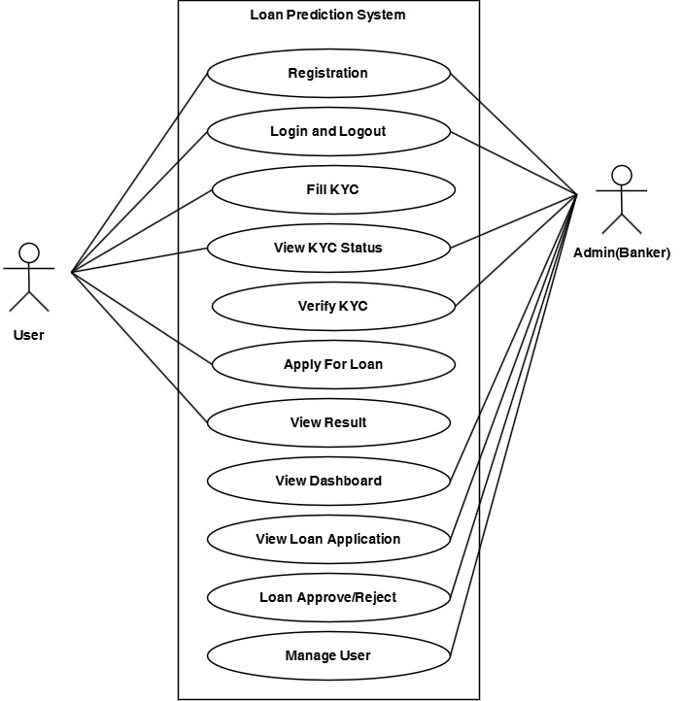

Fig 3.1: Usecase Diagram of Loan Prediction System

3.1.5 Non-Functional Requirements

Table 3.4: Non-Functional Requirements
Requirement | Description
Performance & Speed | The system must be fast enough to support real-time or near-real-time decision-making. The trained model should be loaded into memory for efficient reuse across prediction requests.
Accuracy & Reliability | The predictive model must prioritize minimizing false negatives (missing actual defaulters) to reduce financial risk and NPA, evaluated rigorously using ROC-AUC and PR-AUC scores.
Interpretability | The system must not act as an opaque "black box." Predictions must be transparent and justifiable to loan officers and regulators through global and local explainability.
Usability | The graphical user interface must be accessible and easy to navigate for both everyday applicants and administrative staff, utilizing standard web frameworks (HTML, CSS, Bootstrap).
Security | Applicant data, KYC records, and sensitive financial information must be securely managed using Django's built-in authentication and authorization systems and stored safely in the database.

3.2 Feasibility Study
1. Technical Feasibility
The project is technically feasible as it relies on well-established, open-source technologies. Python provides a rich ecosystem for machine learning (pandas, scikit-learn, CatBoost, XGBoost, LightGBM, SHAP), while Django offers a robust framework for web deployment. The system can be developed and run on standard consumer hardware without the strict necessity of GPU acceleration.

2. Operational Feasibility
The system is operationally feasible as it addresses a direct operational bottleneck in the banking sector: the manual review of large volumes of loan applications. By acting as an automated decision-support tool that integrates seamlessly into a web interface, it enhances rather than disrupts the existing workflows of loan officers.

3. Economic Feasibility
The project is highly economically feasible. Development relies entirely on open-source, freely available software and libraries, eliminating licensing costs. From a business perspective, the system is designed to reduce the financial losses associated with incorrect loan approvals and rising NPA, providing a strong return on investment.

4. Schedule Feasibility
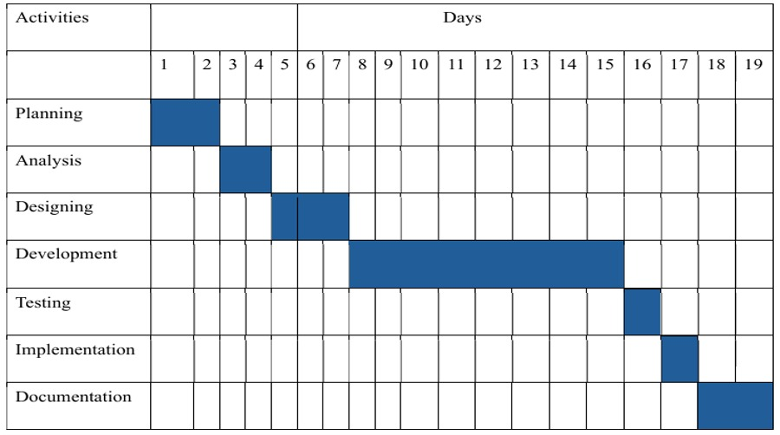
Figure 3.2: Gantt Chart of Time Schedule

The scope of the project, including data preprocessing, model evaluation, and web deployment, was designed to be carried out under supervision and completed successfully within the time frame prescribed by the university syllabus.

3.3 Constraints and Assumptions
1. Constraints:
- Scope Limitation: The system focuses strictly on predicting the binary outcome of loan default based on tabular financial data. It does not perform other lending workflow tasks such as collateral valuation, legal document checks, or fraud detection.
- Static Model: Once trained and serialized, the machine learning model does not automatically update. It is susceptible to "model drift" over time if economic conditions or borrower behaviors change, requiring periodic manual retraining.
- Feature Availability: The system's predictive ceiling is constrained by the features present in the Kaggle dataset; it lacks access to potentially highly predictive real-world data like past repayment history or total applicant net worth.

2. Assumptions
- It is assumed that the dataset sourced from Kaggle is a sufficiently accurate representation of real-world applicant profiles and financial distributions.
- It is assumed that users interacting with the system will provide accurate and truthful demographic and financial information during the application process.

3.4 Analysis
1. Process modelling
1. Data Flow Diagram (0 Level DFD)
The Level 0 Data Flow Diagram provides a high-level overview of the system by showing the flow of information between external entities and the Loan Prediction System.
The primary external entities are the User and the Admin. Users provide registration information, KYC documents, and loan application details to the system. The system processes these inputs and returns KYC status updates and prediction results. Administrators interact with the system to verify KYC information, review loan applications, and make approval decisions. All data is stored and retrieved from the system database.
The DFD Level 0 focuses on the overall movement of data without exposing internal processing details.
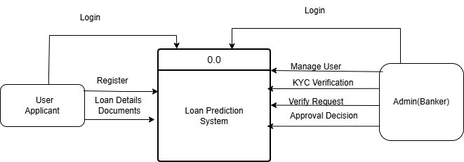

Figure 3.3: DFD Level 0 of the Loan Prediction System

2. Data Flow Diagram (1 Level DFD)
The Loan Prediction System begins with the user entering registration details in the User Management module, where the information is stored in the User Database. The admin manages and monitors the system through Admin Management. After registration, the user completes the KYC (Know Your Customer) process by submitting required documents, which are stored in the KYC Database. The user then submits a loan application with details such as income, employment status, and loan amount. The system uses a CatBoost machine learning model to analyze the application data and predict whether the loan should be approved. The prediction results are stored in the Prediction Database, and SHAP Explainability is used to explain the factors affecting the prediction. Finally, based on the analysis, the system provides the loan decision as either approved or rejected.

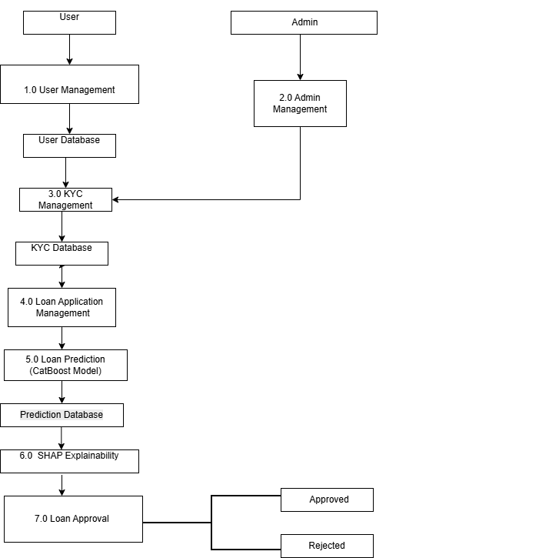

Figure 3.4: DFD Level 1 of the Loan Prediction System

4. SYSTEM ARCHITECTURE AND METHODOLOGY

4.1 Overall System Architecture
The proposed Loan Prediction System is a web-based machine learning application developed to assist financial institutions in evaluating loan applicants. The system follows a layered architectural design that integrates user management, Know Your Customer (KYC) verification, machine learning-based risk prediction, explainable artificial intelligence (XAI), and administrative decision-making.
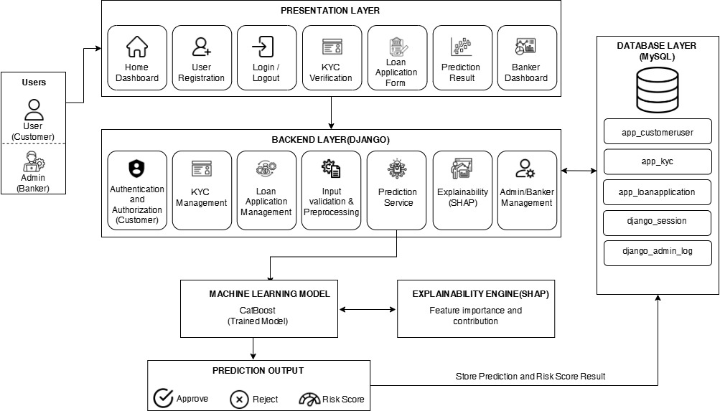

Figure 4.1:System Architecture

The architecture is divided into five core layers:
- Presentation Layer: Provides the graphical user interface developed using Django templates, HTML, CSS, Bootstrap, and JavaScript. It includes dedicated dashboards for applicants (registration, KYC submission, loan application) and administrators (monitoring, verification, and decision-making).
- Backend Layer: Contains the business logic of the application, managing authentication, KYC validation, form processing, and bridging the user interface with the predictive models.
- Machine Learning Layer: Houses the pre-trained CatBoost classifier. It receives validated applicant attributes and generates a binary prediction and probability score.
- Explainability Layer: Utilizes SHAP to decompose the model's prediction into feature contributions, ensuring transparency.
- Database Layer: Implemented using MySQL via the Django Object-Relational Mapper (ORM), storing all system data including user profiles, KYC records, application details, and administrative logs.

4.2 System Flow and Operational Pipeline
The operational workflow clearly separates the offline model development phase from the online inference phase, ensuring a seamless user experience from registration to final loan approval.

.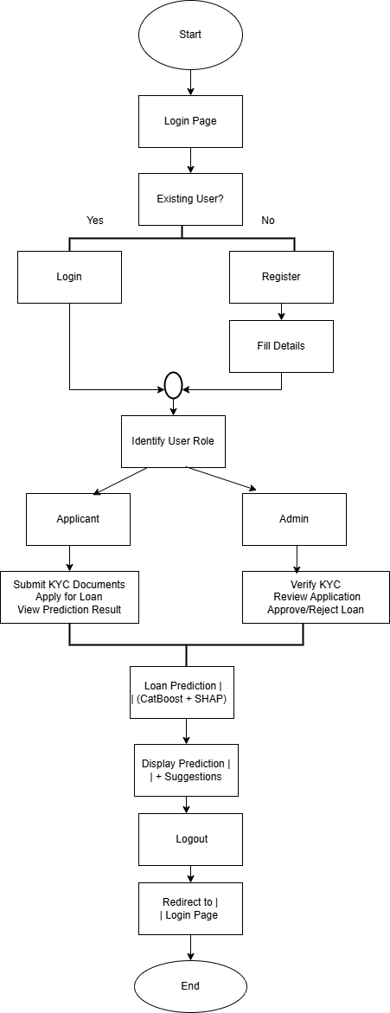

Figure 4.2: System Flowchart

During the online inference phase, the system follows a sequential pipeline:
- Users register, log in, and submit KYC information.
- Administrators verify the submitted KYC documents.
- Verified applicants submit their financial and personal details through a Django-powered web form.
- The backend validates and preprocesses the submitted fields on the server side.
- The preprocessed feature vector is passed to the serialized CatBoost classifier loaded into memory.
- The model outputs a probability score, which is converted to a binary label (Default or Non-Default), alongside SHAP-generated explanatory insights.
- Results are displayed to the user and forwarded to the administrator, who uses both the prediction and the explanation to make a final loan approval or rejection decision.

4.3 UI/UX Design

Figure 4.3: Registration page

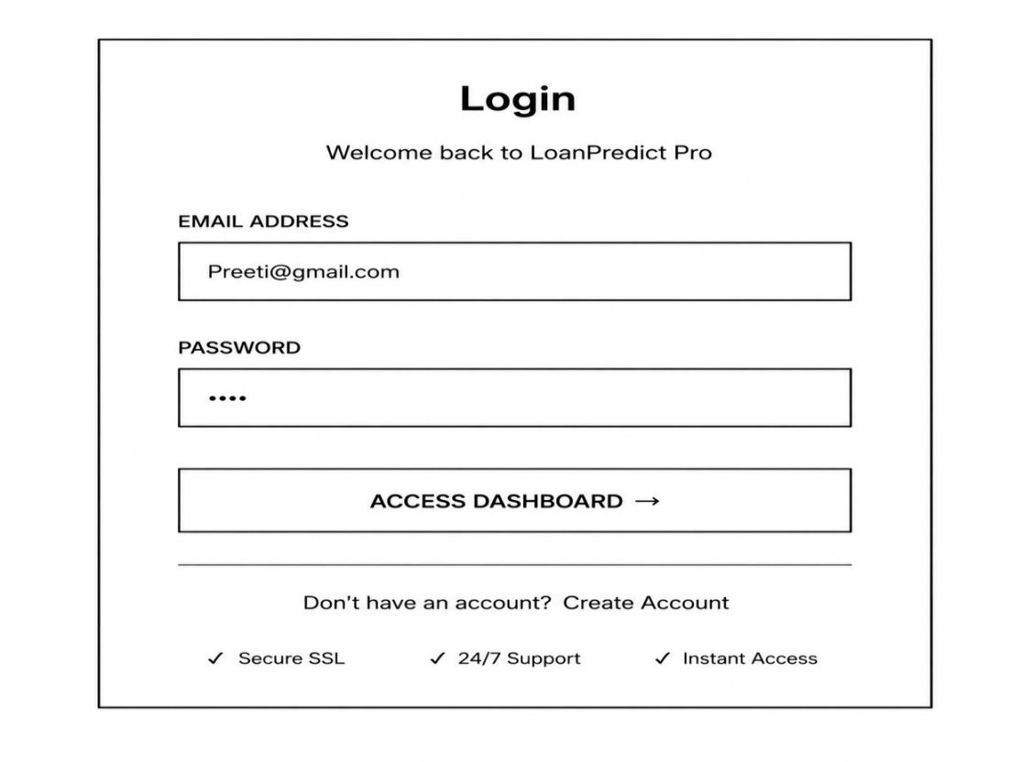
Figure 4.4: Login page

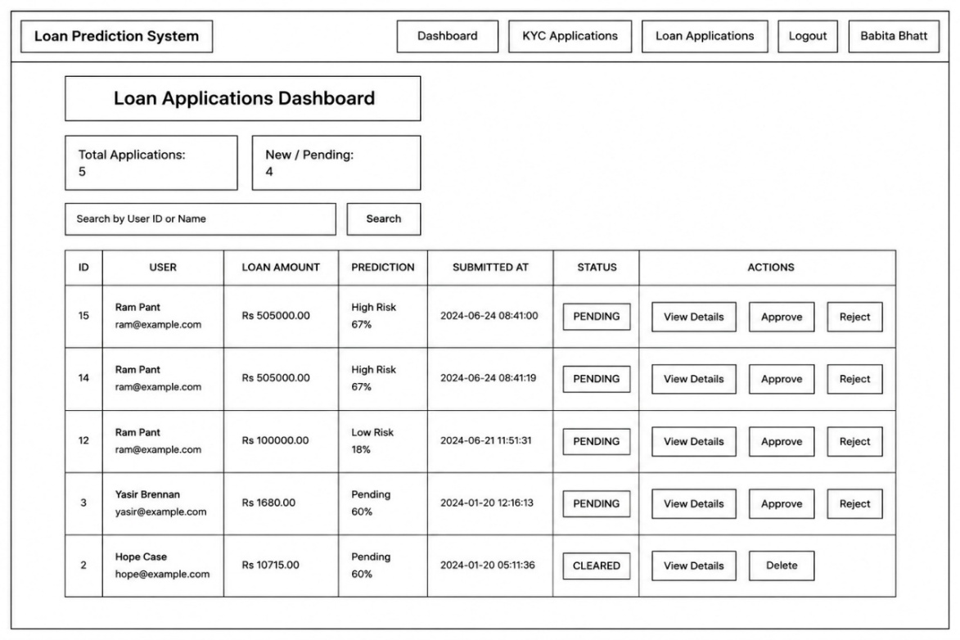
Figure 4.5: Dashboard

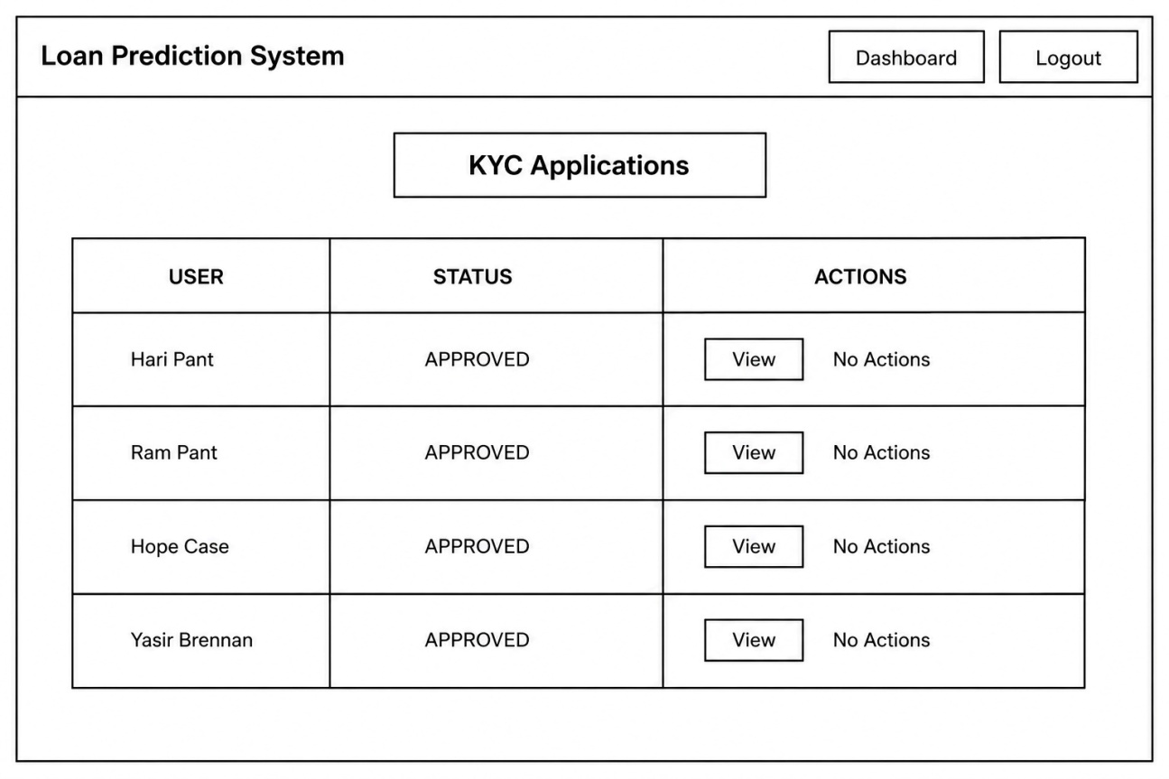
Figure 4.6: KYC Application

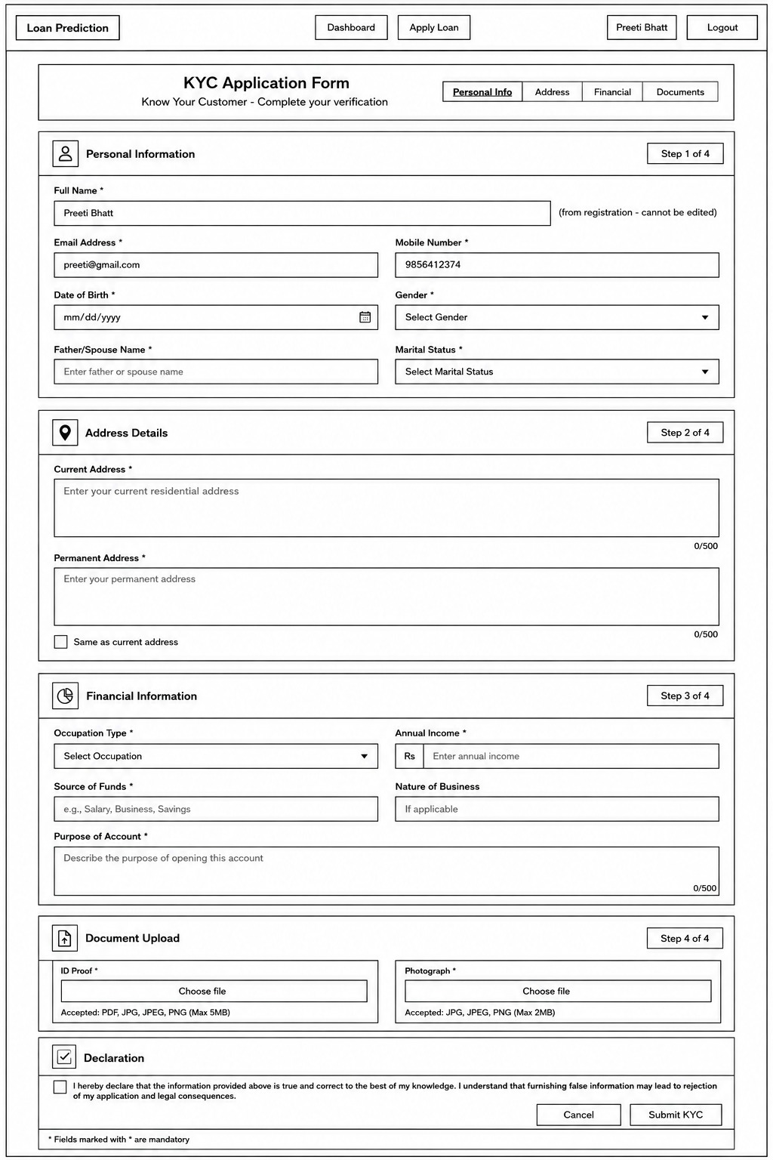
Figure 4.7: KYC Application Form

4.4 Algorithm Used
The primary machine learning algorithm deployed in the Loan Prediction System is CatBoost (Categorical Boosting), a high-performance open-source gradient boosting framework developed by Yandex. It is built upon the architecture of gradient-boosted decision trees (GBDT) but introduces novel modifications to overcome two traditional limitations of gradient boosting: operational inefficiencies when handling categorical features and prediction shift caused by target leakage.
Given that the loan applicant dataset contains critical categorical indicators (such as education level, marital status, and employment type) alongside non-linear financial metrics, CatBoost provides significant architectural advantages over standard GBDTs.

4.4.1 Mathematical Foundation and Gradient Boosting Mechanics
Like traditional gradient boosting methods, CatBoost builds an ensemble model sequentially. At each iteration t, a new base predictor h_{t}(x) is trained to minimize the expected loss function L relative to the pseudo-residuals of the existing ensemble F_{t-1}(x). The ensemble prediction is updated additively:
F_{t}(x) = F_{t-1}(x) + αh_{t}(x)
Where α represents the learning rate (step size). CatBoost optimizes this process using two distinct algorithmic enhancements:

4.4.2 Symmetric Trees (Oblivious Trees)
Unlike XGBoost or LightGBM, which grow trees depth-wise or leaf-wise using asymmetric splits, CatBoost utilizes oblivious trees as base learners.
- In an oblivious tree, the same splitting criterion (feature and threshold) is applied across all nodes at the same depth level of the tree.
- This creates a balanced, highly symmetric tree structure.
- Benefits: This symmetry acts as a powerful regularizer, significantly reducing the risk of overfitting on noisy financial tabular data. Furthermore, at inference time, the execution of a symmetric tree can be evaluated incredibly fast via bitwise operations, allowing the Django web backend to return synchronous credit risk scores instantly.

4.4.3 Ordered Target Statistics for Categorical Features
A frequent issue in tabular machine learning is the processing of high-cardinality categorical variables. Common strategies like one-hot encoding increase dimensionality excessively, while standard target encoding introduces target leakage and conditional shift. CatBoost solves this natively through Ordered Target Statistics (Ordered TS).
Instead of computing the average target value across the entire training dataset to encode a category, CatBoost introduces a synthetic time-based ordering. For a given sample, the categorical feature value is replaced by a numeric score computed using only the historical samples appearing before it in a random permutation σ:
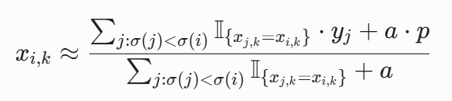
Where:
- 𝕀 is the indicator function.
- 𝑦_{j} is the binary target label (Default = 1, Non-Default = 0).
- 𝑝 is a prior value to prevent division by zero.
- 𝑎 is the weight of the prior.
By computing target statistics strictly on historical subsets via multiple random permutations, the algorithm eliminates target leakage, allowing the model to leverage the predictive power of variables like Education or EmploymentType without overfitting.

4.4.4 Ordered Boosting to Avoid Prediction Shift
Traditional gradient boosting suffers from a subtle structural bias: the pseudo-residuals calculated at iteration t are derived using the same training points that the current model F_{t-1} was already trained on. This creates a shift in the distribution of estimated gradients versus the true population distribution.
CatBoost shifts this paradigm by implementing Ordered Boosting. It maintains a series of independent models trained on varying prefixes of the permuted dataset. When estimating the gradient for a specific sample, CatBoost uses a model instance that has never encountered that sample during its sequential training phase. This ensures un-biased gradient estimations and guarantees robust generalization when evaluated on unseen loan applications in production.

4.5 Dataset Preparation Methodology
4.5.1 Dataset Description
The system was trained on a structured loan default dataset stored as loan_dataset.csv. Each record represents a single loan application, characterized by personal, financial, and loan-specific attributes, along with a binary target column (Default). A value of 0 denotes a non-defaulting borrower, and 1 denotes a defaulter. Prior to training, mutually exclusive binary indicators for loan purposes (Business, Education, Home, Other) were dropped to simplify the input space without degrading predictive performance.

4.5.2 Cleaning and Preprocessing
After loading the dataset into a pandas DataFrame, column names were stripped of whitespace to correct inconsistencies. Features were partitioned into numeric and categorical subsets. No imputation was required due to a lack of null entries, but type consistency checks were enforced. For Naive Bayes, a StandardScaler was applied to numeric features. Tree-based models required no feature scaling.

4.5.3 Label Distribution and Class Imbalance
To address the realistic class imbalance between the Non-Default majority and the Default minority, specific strategies were applied per model:
- Naive Bayes: Evaluated using SMOTE-resampled (synthetic minority generation) and undersampled training sets.
- Decision Tree: The class_weight parameter was set to balanced to adjust the impurity criterion.
- XGBoost: The scale_pos_weight parameter was set to the ratio of negative to positive samples.
- LightGBM: Configured to handle imbalanced data internally using is_unbalance=True or by providing explicit class weights.
- CatBoost: Explicit class weights were provided, matching the ratio of non-default to default samples.

4.5.4 Train-Test Split
All models utilized an identical 80/20 stratified split (test_size=0.2, stratify=y, random_state=42) to preserve the target class ratio across both partitions and guarantee reproducible comparisons.

4.6 Feature Engineering and Preprocessing
4.6.1 Complete Feature Set
The model accepts 20 input columns after one-hot encoding. Features fall into three categories:
- Demographic: Age, Education, EmploymentType, MaritalStatus, HasDependents.
- Financial: Income, CreditScore, MonthsEmployed, NumCreditLines, DTIRatio, HasMortgage.
- Loan-Specific: LoanAmount, InterestRate, LoanTerm, HasCoSigner.

4.6.2 Categorical Feature Encoding
The categorical features were transformed into numerical representations using one-hot encoding to ensure compatibility with the machine learning models. During inference, the prepare_user_input() function applies the same encoding scheme used during model training, converting user-submitted data into an identical 20-column feature matrix. This ensures consistent feature ordering and prevents feature mismatch between the training and prediction stages. The final input feature set used by the deployed model is presented in Table 4.x.

Table 4.1: One-Hot Encoding of Categorical Variables
S.N | Column | Dtype
1 | Age | int64
2 | Income | int64
3 | MonthsEmployed | int64
4 | LoanAmount | int64
5 | CreditScore | int64
6 | NumCreditLines | int64
7 | InterestRate | float64
8 | LoanTerm | int64
9 | DTIRatio | float64
10 | Education_High School | bool
11 | Education_Master's | bool
12 | Education_PhD | bool
13 | EmploymentType_Part-time | bool
14 | |EmploymentType_Self-employed | bool
15 | EmploymentType_Unemployed | bool
16 | MaritalStatus_Married | bool
17 | MaritalStatus_Single | bool
18 | | HasMortgage_Yes | bool
19 | HasDependents_Yes | bool
20 | HasCoSigner_Yes | bool

The Default column was excluded from the feature matrix during training and used as the target label (y).

4.7 Model Training Methodology
The offline machine learning pipeline encompasses data ingestion, processing, model comparison, evaluation, and the final integration of explainability metrics.
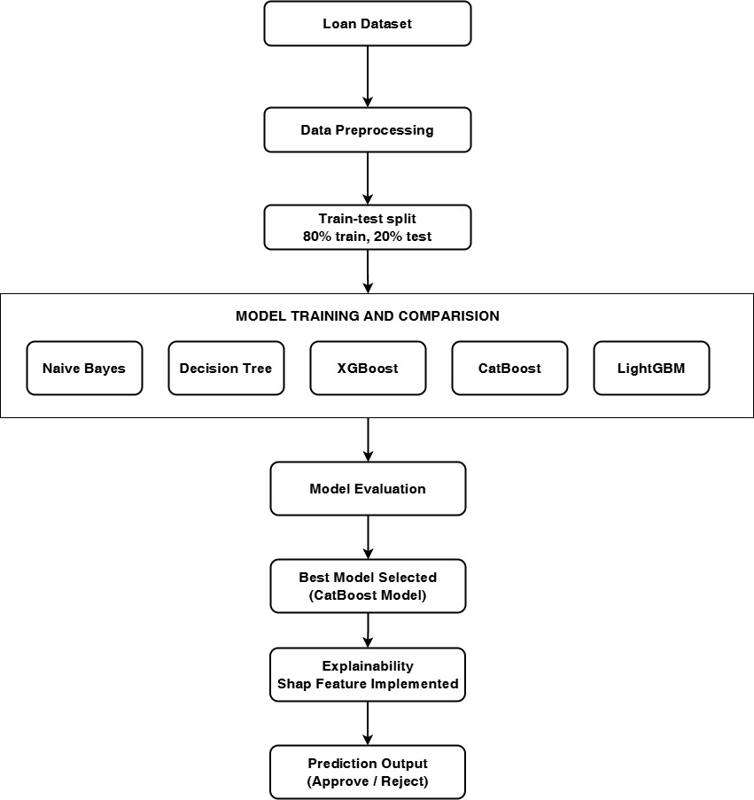

Figure 4.8: ML Model Development Workflow Diagram

Five supervised binary classifiers were trained and evaluated during the model comparison phase:
- Gaussian Naive Bayes: A probabilistic baseline that models each feature's class-conditional distribution as a Gaussian and applies Bayes' theorem to compute the posterior probability of each class. It requires scaled numeric features and is sensitive to class imbalance.
- Decision Tree: A single-tree classifier that partitions the feature space using a sequence of axis-aligned binary splits chosen to minimize a node impurity criterion. Hyperparameters were tuned via grid search with three-fold cross-validation.
- XGBoost: A gradient boosting algorithm that trains trees sequentially, where each successive tree is fit to the residual errors of the current ensemble. The model was configured with n_estimators=500, max_depth=6, learning_rate=0.05, and scale_pos_weight set to the negative-to-positive training ratio.
- LightGBM: A highly efficient gradient boosting framework utilizing a leaf-wise (best-first) tree growth strategy. This allows for faster convergence and lower memory consumption, capturing deep, non-linear interactions among financial indicators with high computational efficiency.
- CatBoost: A gradient boosting framework developed specifically for datasets containing categorical features. It builds symmetric trees to reduce overfitting and utilizes built-in ordered target statistics.

4.7.1 Model Selection Logic
Tree-based models were prioritized because they excel on compact, structured tabular data, capture nonlinear interactions efficiently, and do not require feature scaling. CatBoost was selected as the final deployed model. It provided the strongest balance of minority-class recall, PR-AUC, and false-positive reduction, which is operationally critical for risk management where missing a true default carries a high financial cost.

4.8 Explainability and Recourse Methodology
A distinctive feature of the Explainability Layer is the prediction explanation and recourse generation module. After CatBoost produces a probability score, a SHAP TreeExplainer decomposes the prediction into per-feature contributions. These are displayed as a feature importance bar chart, allowing administrators and applicants to understand the specific decision drivers.
Additionally, a counterfactual recourse module identifies minimum required changes for rejected applicants to achieve a Non-Default prediction. Features are classified as immutable (e.g., age), slow-moving (e.g., credit score), or immediately actionable (e.g., loan amount). The module outputs human-readable recommendations based on optimizations of these actionable features.

4.9 Inference and Web Application Methodology
4.9.1 Application Architecture and Input Processing
The Django application serves as the core framework. At server startup, the pre-trained CatBoost model is loaded into memory via joblib. When an applicant submits a form, the view extracts the values, casts numerics to floats, and maps categoricals using the prepare_user_input function.

4.9.2 Prediction Output
The model's predict_proba method returns a probability vector. The Default class probability serves as the anomaly score, while the predict method generates the binary label. The final response is rendered synchronously in the browser, showing the risk classification, confidence percentage, and SHAP insights, which the Admin uses to execute the final system workflow.

4.10 Evaluation Methodology
Models were evaluated on the held-out 20% test partition using a fixed decision threshold of 0.5. The evaluation metrics include:

Table 4.2: Evaluation metrices
Metric | Description
Accuracy | The overall proportion of correctly classified records.
Precision | The proportion of predicted Defaults that are actual defaults.
Recall (Sensitivity) | The proportion of true defaults correctly identified.
F1-Score | The harmonic mean of precision and recall.
ROC-AUC | The area under the Receiver Operating Characteristic curve.
PR-AUC | The area under the Precision-Recall curve; highly sensitive to minority-class retrieval.
Confusion Matrix | A discrete breakdown of true positives, true negatives, false positives, and false negatives.

4.11 Design Rationale
- Tree-Based Models over Deep Learning: The feature space is a compact 20 columns. Gradient boosting methods are the established state-of-the-art for such tabular data, avoiding the massive data requirements and complexity of neural networks.
- CatBoost as the Deployed Model: CatBoost yielded the best minority-class recall and PR-AUC. Its native SHAP integration and robust class-weight parameters made it ideal for an explainable financial system.
- Django as the Unified Framework: Utilizing Django allowed for seamless integration of the Python-based machine learning pipeline with secure user authentication, KYC workflows, and MySQL database management, eliminating cross-language overhead.

5. IMPLEMENTATION AND TESTING

5.1 Implementation
This chapter describes the implementation of the Loan Prediction System. The system was developed as a Django-based web application integrated with a machine learning model for loan default prediction. The implementation includes the software tools and technologies used, the project architecture, explainability components, natural language reporting, and the functional modules developed within the application.

5.1.1 Tools and Technologies Used
The Loan Prediction System was developed using various frontend, backend, machine learning, and database technologies. These tools were selected to provide a scalable, secure, and efficient prediction platform.
A. Frontend Technologies
The frontend provides an interactive interface for customers and bankers to access the system.
1. HTML
HTML was used to design the structure of the web pages, including user registration, login pages, KYC forms, loan application forms, dashboards, and prediction result pages.
2. CSS
CSS was used to improve the appearance of the web application by providing layouts, colors, typography, spacing, and responsive page design.
3. JavaScript
JavaScript was used to perform client-side validation and improve user interaction by enabling dynamic page updates and responsive form behavior.

B. Backend Technologies
The backend performs business logic, machine learning prediction, user management, and database operations.
1. Python
Python was used as the primary programming language because of its extensive support for web development, machine learning, and data analysis.
2. Django Framework
Django served as the backend web framework. It manages URL routing, authentication, form processing, database interaction through the ORM, and rendering of web pages using the Model–View–Template (MVT) architecture.
3. CatBoost
CatBoost was used as the machine learning algorithm for loan default prediction. The trained model was serialized and integrated into the Django application for real-time prediction.
4. SHAP
SHAP was used to explain model predictions by identifying the features that most influenced each prediction, enabling transparent and interpretable decision-making.
5. SciPy
SciPy was used to generate counterfactual recommendations through optimization techniques, allowing the system to suggest minimal changes required for improving loan approval chances.
6. Pandas
Pandas was used for preprocessing applicant information and preparing feature vectors before passing them to the prediction model.
7. MySQL
MySQL was used as the primary database management system for storing user information, KYC records, loan applications, prediction history, and system logs.
8. SQLite
SQLite was used during local development and testing before deployment.
9. Grok API
The Grok API was integrated to generate personalized financial advisory reports based on prediction results, SHAP explanations, and counterfactual recommendations.
10. VS Code
Visual Studio Code was used as the primary integrated development environment (IDE) for coding, debugging, and project management.

5.1.2 Implementation Details of Modules
The Loan Prediction System consists of several functional modules that work together to provide a complete loan prediction platform.
1. User Registration and Authentication Module
This module provides secure registration, login, logout, and password management for Customers and Bankers. Django's authentication framework is used to implement role-based access control, ensuring users can access only the features permitted for their role.
Key features include:
- Customer and Banker registration
- Secure login and logout
- Role-based authorization
- Password encryption and authentication

2. KYC Verification Module
The KYC module manages customer identity verification before loan applications can be submitted.
Key features include:
- Upload of identity documents
- Banker verification of submitted KYC documents
- KYC status tracking
- Restriction of loan application until verification is completed

3. Loan Prediction Module
This module performs the core machine learning prediction.
When a customer submits the loan application form, the system validates the input data and converts it into the same feature format used during model training. The serialized CatBoost model is then loaded to predict both the probability of loan default and the final prediction outcome.
Key features include:
- Loan application processing
- Feature preprocessing
- CatBoost prediction
- Risk probability estimation
- Prediction result generation
4. Explainability Module
This module improves transparency by explaining why the prediction was made.
SHAP values are computed for every prediction to determine how each feature contributes to the final decision. The module identifies the most influential features and indicates whether each factor increases or decreases the predicted default risk.
For applicants predicted as high risk, a counterfactual explanation is generated. The optimization process recommends realistic modifications to selected financial attributes, helping applicants understand the minimum changes required to improve their predicted outcome.
Key features include:
- SHAP feature importance calculation
- Feature contribution analysis
- Counterfactual recommendation generation
- Identification of actionable financial improvements

5. Financial Report Generation Module
This module converts technical prediction outputs into user-friendly financial reports.
A Financial Health Score is calculated using multiple financial indicators including credit score, debt-to-income ratio, income level, and employment stability. The module also summarizes SHAP explanations and counterfactual recommendations into structured tables.
When available, the Grok API generates a personalized financial advisory report in natural language. If the API is unavailable, the system automatically generates a template-based report locally.
Key features include:
- Financial Health Score calculation
- SHAP summary generation
- Counterfactual recommendation summary
- AI-generated financial advisory report
- Offline fallback report generation

6. Dashboard Module
The dashboard provides different interfaces for Customers and Bankers.
Customer Dashboard:
- View KYC status
- Submit loan applications
- View prediction history
- Access generated reports
Banker Dashboard:
- Review KYC requests
- Monitor loan applications
- View prediction history
- Access customer reports

7. Administration Module
The administration module extends Django's built-in administration panel to manage the entire system.
Key features include:
- User management
- Loan application management
- Prediction record management
- System monitoring
- Database administration

5.1.3 Prediction Workflow
The prediction workflow begins when a customer submits a loan application. The application data is first validated using Django forms. After successful validation, the applicant's information is preprocessed into the same feature representation used during model training.
The processed data is then passed to the trained CatBoost model, which calculates the probability of loan default and predicts whether the loan should be approved or rejected.
Following prediction, the SHAP explainability module identifies the most influential features affecting the decision. If the applicant is classified as high risk, the counterfactual module generates recommendations showing the minimum changes required to reduce the predicted default risk.
Finally, the Financial Health Score is calculated, and a comprehensive financial advisory report is generated. All prediction results, explanations, and application details are stored in the database before the final prediction page is displayed to both the customer and the banker.

5.2 Testing

5.2.1 Test Cases for Unit Testing

Table 5.1: Signup with valid data
Test ID | Test scenario | Test Steps | Test Data | Expected Result | Actual Result
T01 | User signup checking | Fill all the details like( Username, Email, Phone number,  Password, Confirm Password | Username: Babita Bhatt Email: babita@gmail.com  Phone No.:9834343434  Password:12345678 ConfirmPassword:12345678 | User was Registered | As Expected

Table 5.2: Signup with invalid data
Test ID | Test scenario | Test Steps | Test Data | Expected Result | Actual Result
T02 | User signup checking | Fill all the details like( Username, Email, Phone number,  Password, Confirm Password | Username: Babita Bhatt Email: babita@gmail.com  Phone No.:5434343434  Password:123456 78ConfirmPassword:12345678 | An error Showing “Please match the requested format” | As Expected

Table 5.3: Login with valid data
Test ID | Test scenario | Test Steps | Test Data | Expected Result | Actual Result
T03 | User login checking | Enter Email and Password | Email: babita@gmail.com Password:12345678 | User logged in and  redirected to dashboard | As Expected

Table 5.4: Login with invalid data
Test ID | Test scenario | Test Steps | Test Data | Expected Result | Actual Result
T04 | User login checking | Enter Email and Password | Email: babita@gmail.com Password:12345 | An error Showing  “Invalid email or password” | As Expected

Table 5.5: KYC Application Form
Test ID | Test scenario | Test Steps | Test Data | Expected Result | Actual Result
T05 | Submit service request | Fill kyc form and submit | Personal Info(Full Name  EmailAddress  Mobile Number  Date of Birth  Father/Spouse Name  Marital Status)  Address(Current Address  Permanent Address)  Financial(Occupation Type,Annual Income,Source of funds,nature of business,purpose of account)  Documents(ID proof ,photofraph) | Message “ Submitted Successfully” | As Expected

Table 5.6: KYC result
Test ID | Test scenario | Test Steps | Test Data | Expected Result | Actual Result
T06 | User Applications | User kyc form checkup | Approve,reject | Approved or rejected by seeing user data | As Expected

Table 5.7: loan application
Test ID | Test scenario | Test Steps | Test Data | Expected Result | Actual Result
T07 | User fillup loan form | Loan form fillup and submit | Personal Info(Age,Annual income,loan amount,credit score,months employed,interest rate,loan term,  Debt-to-Income Ratio)  Employment and education( Education level,employment type,martial status)  Additional Information | Loan submit | As Expected

Table 5.8: loan applicants
Test ID | Test scenario | Test Steps | Test Data | Expected Result | Actual Result
T08 | Approve or Reject loan request | Showing loan applications | Loan applications | Status updated to “Approved or Rejected” | As Expected

5.2.2 Test Cases for System Testing

Table 5.9: System Tests
Test  ID | Test  Scenario | Test Steps | Test Data | Expected  Result | Actual  Result
T01 | User signup checking | Fill all the details like( Username, Email, Phone number,  Password, Confirm Password | Username: Babita Bhatt Email: babita@gmail.com  Phone No.:9834343434  Password:12345678 ConfirmPassword:12345678 | User was Registered | As Expected

T02 | User signup checking | Fill all the details like( Username, Email, Phone number,  Password, Confirm Password | Username: Babita Bhatt Email: babita@gmail.com  Phone No.:9834343434  Password:12345  ConfirmPassword:12345678 | An error Showing “Invalid Email format” | As Expected
T03 | User login checking | Enter Email and Password | Email:babita@gmail.com  Password:12345678 | User logged in and redirected to dashboard | As Expected
T04 | User login checking | Enter Email and Password | Email:babita@gmail.com  Password:12345 | An error Showing “Invalid  Username or password” | As Expected
T05 | Submit loan request | Fill request form and submit | Age:35  Annual Income : 120000  Loan Amount: 10000  Credit Score:780  Months Employed:96  Interest Rate: 6.5  Loan Term:36  Debt-to-Income Ratio:0.18  Education Level:Master's  Employment Type:Full-Time | Message “Risk probability: 14.7%  ” | As Expected
T06 | Submit loan request | Fill request form and submit | Age:22  Annual Income : 200000  Loan Amount:50500000  Credit Score:780  Months Employed:96  Interest Rate: 6.5  Loan Term:12  Debt-to-Income Ratio:0.18  Education Level:High school  Employment Type:part-Time | Message “ High Risk probability: 71% | As Expected

T12 | View  submitted complaints | Open Complaint  Management page | Existing complaints | Complaint  records displayed | As Expected
T13 | View system logs | Open System Logs page | Existing log records | Logs displayed  successfully | As Expected
T14 | View  dashboard statistics | Login as Admin | Dashboard data available | Statistics  displayed successfully | As Expected

6. RESULTS AND ANALYSIS
This chapter presents the results obtained from training and evaluating five machine learning models on the loan default prediction dataset, along with an analysis of their performance characteristics. The results are reported using confusion matrices, ROC-AUC scores, and PR-AUC scores metrics chosen specifically because of the significant class imbalance present in the dataset (88.38% non-default vs. 11.62% default). Relying solely on accuracy would be misleading in such a scenario, as a trivial classifier that always predicts non-default would achieve 88.38% accuracy without providing any predictive value. ROC-AUC measures the model's ability to discriminate between the two classes across all possible decision thresholds, while PR-AUC focuses specifically on the model's precision and recall performance on the minority (default) class, making it the more stringent and practically relevant metric in this context. Following the model comparison, this chapter also presents the SHAP-based explainability results and discusses the sources of error and limitations observed in the system.

6.1 Model Performance Results
All five models were evaluated on the same held-out test set of 51,070 records, produced by an 80:20 stratified split of the full dataset. The subsections below present the confusion matrix and metric scores for each model individually, followed by a consolidated comparative analysis.

6.1.1 Confusion Matrix Interpretation
A confusion matrix for binary classification reports four values: True Negatives (TN) non-defaulters correctly predicted as non-default; False Positives (FP) non-defaulters incorrectly predicted as default; False Negatives (FN) actual defaulters incorrectly predicted as non-default; and True Positives (TP) actual defaulters correctly predicted as default. In the context of loan default prediction, False Negatives are the most costly error from a banking perspective, as they represent high-risk applicants who are incorrectly approved and are likely to default, directly contributing to NPA. False Positives, while less financially damaging, represent missed business opportunities where creditworthy applicants are incorrectly rejected.

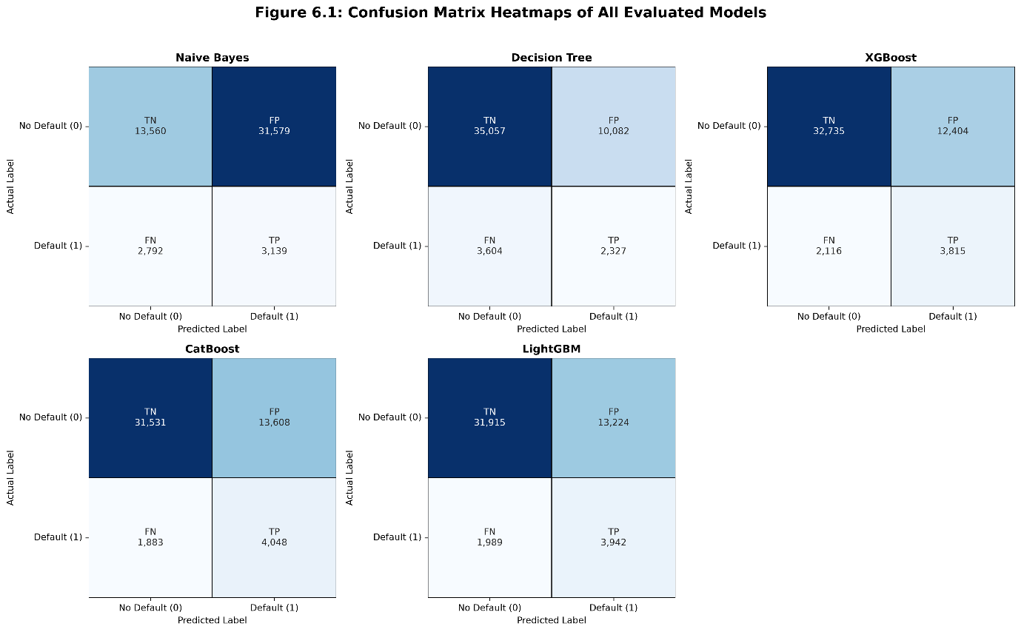

Figure 6.1: Confusion matrix heatmaps of all evaluated models.

Naive Bayes
The Gaussian Naive Bayes model achieved a ROC-AUC score of 0.7314 and a PR-AUC score of 0.2766. The model correctly identified 3,876 defaulters (TP) while missing 2,055 actual defaulters (FN). It also correctly classified 31,061 non-defaulters (TN) but generated 14,078 false positives (FP). Although the model demonstrated reasonable capability in detecting default cases, the high number of false positives indicates a tendency to classify many creditworthy applicants as high-risk borrowers. This would result in a substantial number of unnecessary loan rejections in a real-world banking environment. The relatively low PR-AUC score further suggests that the model struggles to maintain precision when identifying the minority default class. These limitations can be attributed to the strong feature independence assumption of Naive Bayes, which is often unrealistic for correlated financial variables such as income, loan amount, and debt-to-income ratio.

Decision Tree
The Decision Tree model produced the weakest overall performance among the five evaluated models, achieving a ROC-AUC score of 0.5923 and a PR-AUC score of 0.2122. The model correctly identified 35,057 non-defaulters (TN), the highest TN count among all models, while producing 10,082 false positives (FP). However, it also generated the highest number of false negatives, missing 3,604 actual defaulters (FN) and correctly identifying only 2,327 defaulters (TP). This indicates that the model was heavily biased toward the majority non-default class and struggled to detect high-risk applicants. Since false negatives represent the most costly classification error in loan risk assessment, the large FN count significantly reduces the practical usefulness of the model. The low ROC-AUC and PR-AUC scores further confirm its limited ability to distinguish between defaulters and non-defaulters.

XGBoost
XGBoost delivered strong predictive performance with a ROC-AUC score of 0.7524 and a PR-AUC score of 0.3230. The model correctly classified 3,815 defaulters (TP) while missing 2,116 defaulters (FN). It also correctly identified 32,735 non-defaulters (TN) and produced 12,404 false positives (FP). Compared with Naive Bayes and Decision Tree, XGBoost achieved a substantially better balance between detecting default cases and controlling classification errors. The relatively low false negative count demonstrates its effectiveness in identifying high-risk borrowers, which is particularly important in credit risk management. The model's use of gradient boosting, regularization techniques, and class imbalance handling contributed to its improved minority-class performance and overall predictive capability.

CatBoost
CatBoost achieved the best overall performance among all evaluated models, recording the highest ROC-AUC score of 0.7584 and the highest PR-AUC score of 0.3321. The model correctly identified 4,048 defaulters (TP), the highest TP count among all models, while producing the lowest false negative count of 1,883 (FN). It also correctly classified 31,531 non-defaulters (TN) and generated 13,608 false positives (FP). From a banking perspective, minimizing false negatives is particularly important because it reduces the likelihood of approving high-risk applicants who may subsequently default on their loans. Although CatBoost produced slightly more false positives than XGBoost, the significant reduction in false negatives and the increase in correctly identified defaulters make this trade-off acceptable. The model's ordered boosting strategy and effective handling of imbalanced data contributed to its superior performance, leading to its selection as the final deployment model.

LightGBM
LightGBM delivered performance very close to that of CatBoost, achieving a ROC-AUC score of 0.7551 and a PR-AUC score of 0.3260. The model correctly identified 3,942 defaulters (TP) while missing 1,989 defaulters (FN). It also correctly classified 31,915 non-defaulters (TN) and generated 13,224 false positives (FP). These results indicate strong capability in identifying default cases while maintaining balanced classification performance across both classes. The model's leaf-wise tree growth strategy and histogram-based learning enabled efficient training and competitive predictive accuracy. Although LightGBM performed slightly below CatBoost across all evaluation metrics, the difference was relatively small, making it a strong alternative for loan default prediction tasks.

Table 6.1: Summary Comparison of All Evaluated Models
Model | TN | FP | FN | TP | ROC-AUC | PR-AUC
Naive Bayes | 31,061 | 14,078 | 2,055 | 3,876 | 0.7314 | 0.2766
Decision Tree | 35,057 | 10,082 | 3,604 | 2,327 | 0.5923 | 0.2122
XGBoost | 32,735 | 12,404 | 2,116 | 3,815 | 0.7524 | 0.3230
CatBoost | 31,531 | 13,608 | 1,883 | 4,048 | 0.7584 | 0.3321
LightGBM | 31,915 | 13,224 | 1,989 | 3,942 | 0.7551 | 0.3260

Table 6.1 summarizes the performance of all five evaluated models. Among them, CatBoost achieved the highest ROC-AUC and PR-AUC scores while also producing the lowest false negative count and the highest true positive count, indicating the strongest capability for identifying loan defaulters. LightGBM and XGBoost also demonstrated strong performance, whereas Naive Bayes and Decision Tree were comparatively less effective, particularly in handling the imbalanced nature of the dataset. These results support the selection of CatBoost as the final model for deployment in the proposed loan prediction system.

6.1.2 ROC Curve Analysis
The ROC (Receiver Operating Characteristic) curve plots the True Positive Rate (Recall) against the False Positive Rate at every possible decision threshold. A model with perfect discrimination produces a curve that reaches the top-left corner, corresponding to an AUC of 1.0, while a random classifier produces a diagonal line with an AUC of 0.50. All three ensemble models — CatBoost, LightGBM, and XGBoost — produced ROC curves that substantially outperform the random baseline, with CatBoost's curve sitting consistently above those of XGBoost and LightGBM across most threshold values. The Decision Tree's ROC curve lies noticeably closer to the diagonal, confirming its weak discriminative ability on this dataset.
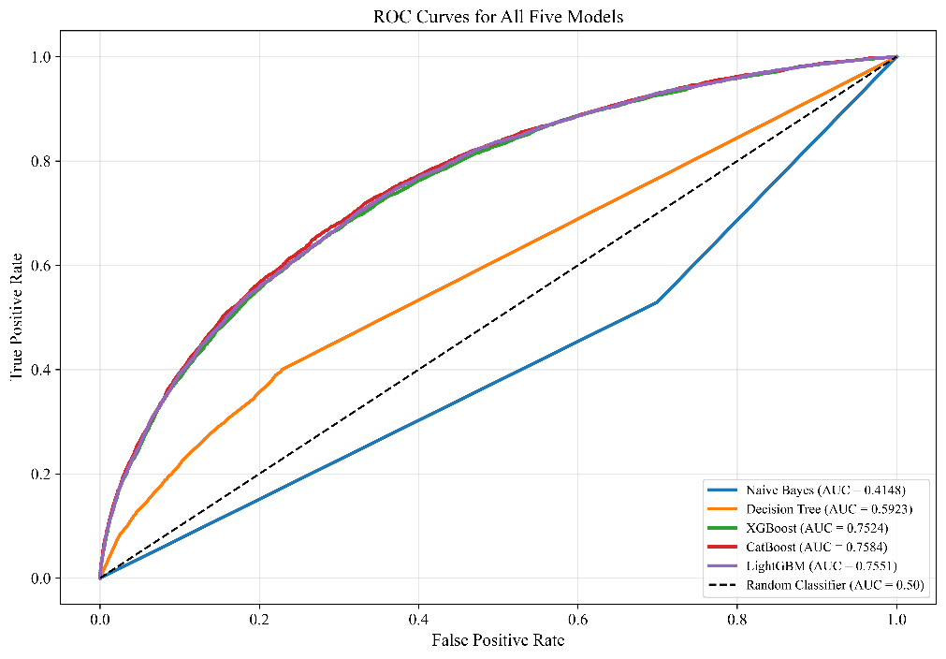

Figure 6.2: ROC Curves for All Five Models.

6.1.3 Precision-Recall Curve Analysis
The Precision-Recall (PR) curve is particularly informative for imbalanced classification tasks. It plots Precision (the proportion of predicted positives that are truly positive) against Recall (the proportion of actual positives correctly identified) across all thresholds. A high PR-AUC indicates that the model can identify a large proportion of actual defaulters while maintaining reasonable precision. CatBoost's PR curve lies above those of all other models across most recall values, confirming its superior ability to detect defaulters without generating an excessively disproportionate number of false alarms. The Decision Tree's PR curve drops sharply at low recall values, indicating poor precision even when the model is tuned to be aggressive about flagging defaults.
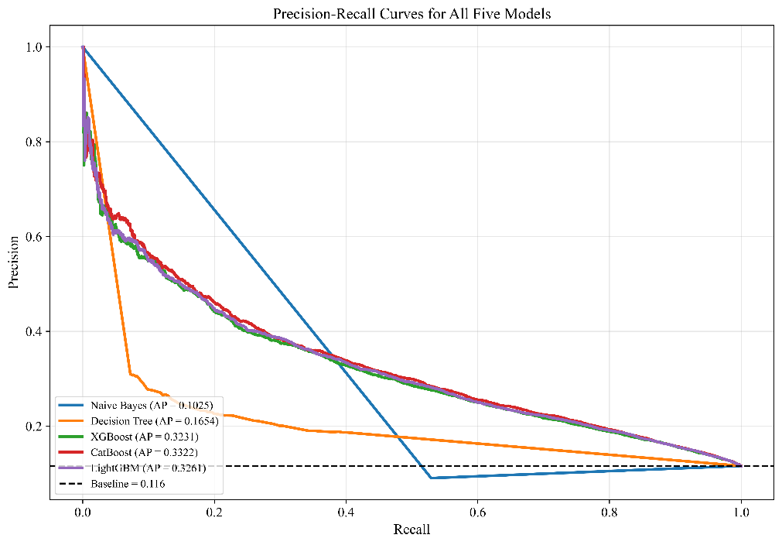

Figure 6.3: Precision-Recall Curves for All Five Models.

6.2 SHAP Explainability Results
6.2.1 Global Feature Importance
SHAP analysis was applied to the final CatBoost model to determine which features most consistently influenced predictions across the entire test set. The SHAP summary violin plot ranks features by their mean absolute SHAP value a measure of the average magnitude of each feature's contribution to the model output and encodes both the direction and distribution of each feature's effect through color and shape.
The analysis confirmed that Age, InterestRate, MonthsEmployed, Income, and LoanAmount were the five most globally influential features, consistent with the CatBoost feature importance ranking shown in Figure 6-7. Higher interest rates were strongly associated with positive SHAP values, pushing predictions toward default, while higher income levels were associated with negative SHAP values, reducing default probability. Notably, Age exhibited a wide, symmetric distribution of SHAP values, suggesting its effect is highly context-dependent younger and older applicants may be assessed differently depending on their broader financial profile. Features such as HasCoSigner, EmploymentType categories, and education-level dummies produced comparatively narrow SHAP distributions, indicating smaller and more uniform contributions across the dataset.

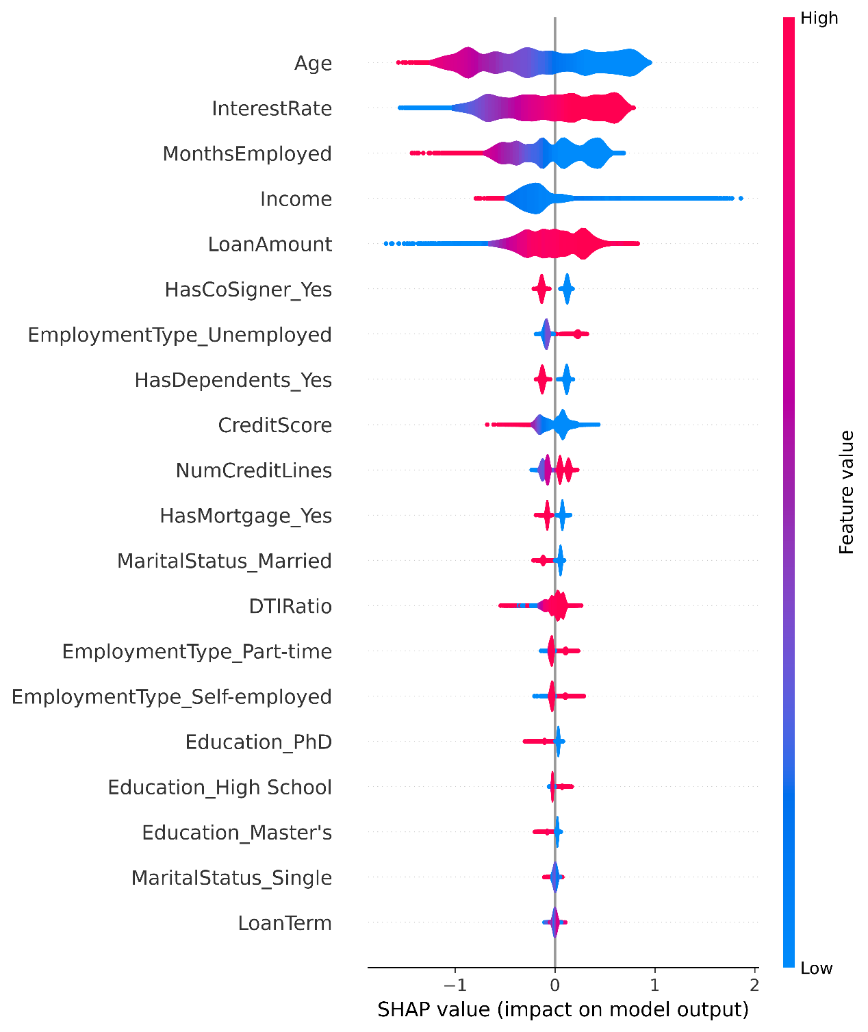

Figure 6.4: SHAP Summary Violin Plot

6.2.2 Individual Prediction Explanation
At the individual prediction level, SHAP waterfall plots were used to explain why a specific applicant received a default prediction. Each waterfall plot begins from the model's baseline expected output denoted as E[f(X)] and sequentially traces how each feature either increases or decreases that baseline to arrive at the final model output f(x) for that specific individual. SHAP values are reported on the log-odds scale, where positive values indicate an increased likelihood of default and negative values indicate a reduced likelihood.
Figure 6-10 illustrates this explanation for the highest-risk applicant identified in the test set, where the model's final output reached f(x) = 3.964 against a baseline of E[f(X)] = 0.001. The dominant risk factor for this applicant was a low annual income of 15,224, which contributed the largest positive SHAP value of +1.61, substantially elevating the predicted default risk. This was compounded by a high loan amount of 231,350 (+0.72), a young age of 25 (+0.63), a high interest rate of 20.32% (+0.42), and only 20 months of employment history (+0.36). The applicant's unemployed employment status further reinforced the high-risk classification (+0.25). Taken together, these six features account for the majority of the upward deviation from the baseline.
Two features provided modest mitigating effects. The presence of dependents (HasDependents_Yes = True) reduced the predicted risk by −0.14, and having only one credit line (NumCreditLines = 1) contributed a further reduction of −0.10. However, the absence of a co-signer (+0.13) and the absence of a mortgage (+0.07) added additional positive risk contributions, partially offsetting these mitigating effects.
This individual-level explanation directly drives the counterfactual feedback mechanism in the web application. The features carrying the largest positive SHAP values for a given applicant in this case Income, LoanAmount, Age, InterestRate, and MonthsEmployed are the ones targeted by the counterfactual loop, ensuring that improvement suggestions are personalized and directly traceable to the model's own reasoning for that specific case rather than generic advice.

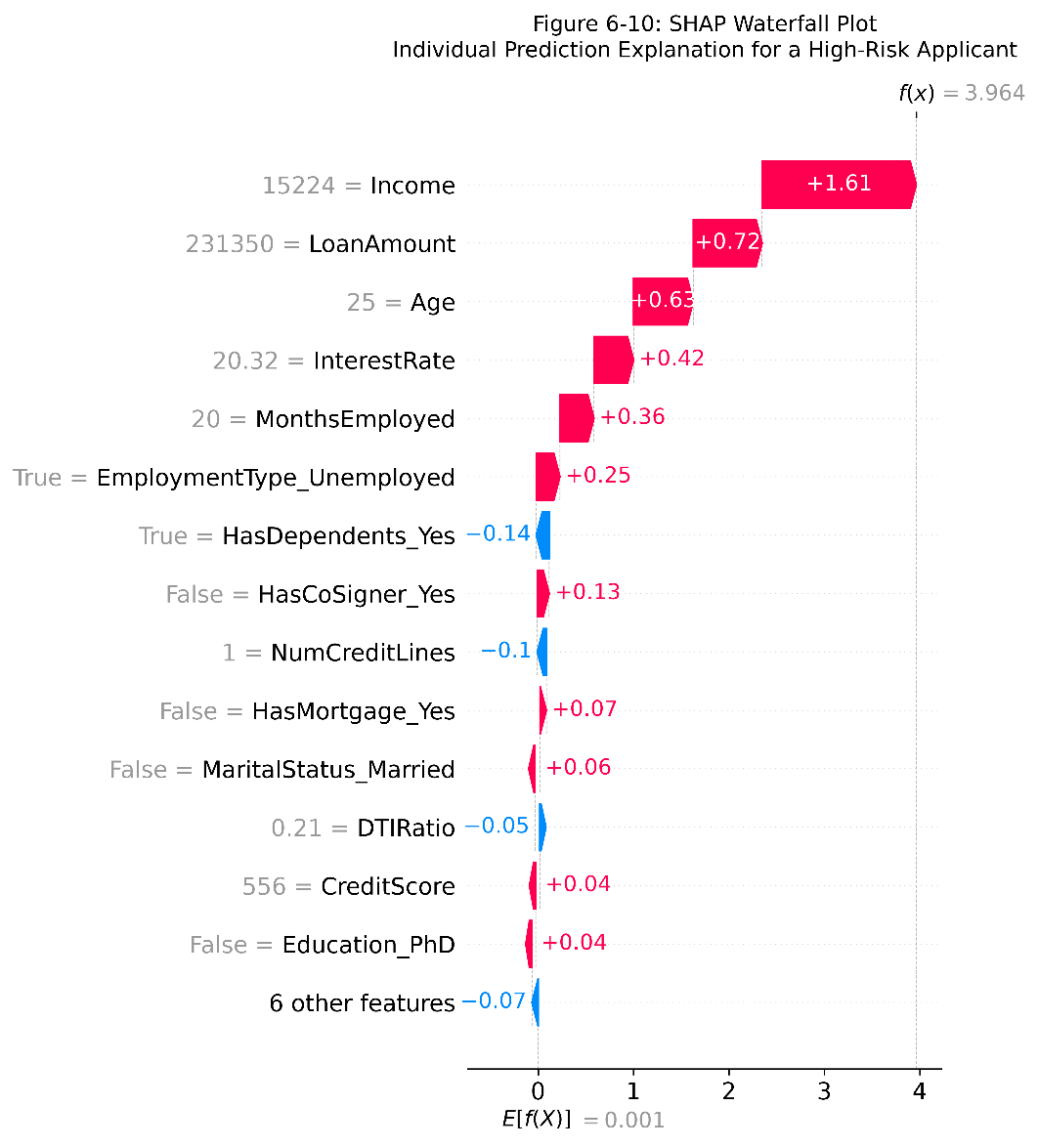

Figure 6.5: SHAP Waterfall Plot - Individual Prediction Explanation for a High-Risk Applicant.

6.3 Error Analysis and Limitations
Despite CatBoost achieving the best performance among all evaluated models, the results also highlight several sources of error and limitations that are important to acknowledge.
The most significant source of error is the persistent class imbalance in the dataset. Even with CatBoost's balanced class-weight handling, the model still produces a substantial number of false positives (13,608) non-defaulters incorrectly predicted as defaulters. This occurs because the model, in its effort to be sensitive to the minority default class, necessarily lowers its decision threshold in a way that increases the likelihood of borderline non-default cases being classified as default. In a production banking system, this trade-off would need to be carefully calibrated based on the relative costs of false positives versus false negatives, possibly through threshold tuning using the PR curve.
A second limitation is that the dataset, while large, may not fully capture the diversity of real-world loan applicants. The categorical feature values are limited to a fixed set (for example, four education categories and four employment types), and the dataset does not include potentially predictive features such as repayment history on previous loans, geographic location, or the applicant's net worth. The absence of such features imposes a ceiling on the achievable predictive performance, which likely explains why CatBoost's ROC-AUC of 0.7584 while strong does not approach the 0.85 to 0.90 range reported in some studies using richer feature sets.

A third limitation relates to the static nature of the deployed model. Once trained and serialized, the CatBoost model does not update itself as new loan application data accumulates in the system. Over time, shifts in economic conditions, borrower behavior, or lending policies may cause the model's learned patterns to become less representative of current risk profiles, a phenomenon known as model drift. Periodic retraining on updated data would be necessary to maintain prediction quality in a long-term production deployment.

7. FUTURE ENHANCEMENTS
Based on the findings and limitations identified throughout this project, the following avenues are proposed for the future development, scaling, and deployment of the system.

7.1 Model and Data Enhancement
The predictive performance of the system is ultimately constrained by the features available in the dataset. Incorporating richer applicant-level data such as repayment history on existing loans, total outstanding debt obligations, savings and asset information, and regional economic indicators — could meaningfully improve model discrimination definition. These features are routinely available in real-world banking environments and would provide the model with a more complete financial profile of each applicant.

7.2 Class Imbalance Handling
While class weighting proved more reliable than SMOTE in this study, advanced imbalance handling strategies warrant further investigation. Techniques such as ADASYN (Adaptive Synthetic Sampling) or cost-sensitive ensemble methods may offer better-calibrated trade-offs between precision and recall on highly imbalanced credit data. Future work should evaluate these approaches under the same dual-metric framework of ROC-AUC and PR-AUC used in this project to ensure a consistent and meaningful comparison.

7.3 Hyperparameter Optimization
Although Optuna did not yield consistent improvements in this study, this may partly reflect the initial search space configuration. Future experiments could explore broader and more targeted search spaces, incorporate multi-objective optimization to simultaneously balance ROC-AUC and PR-AUC, or apply Bayesian optimization frameworks with longer evaluation budgets to more thoroughly map the model's parameter landscape.

7.4 System and Deployment Enhancements
- Predictive Simulation: The counterfactual feedback engine could be extended to simulate the predicted impact of each suggested change before reapplication, giving applicants a clearer and more quantified understanding of how specific improvements affect their score.
- Staff Monitoring Dashboard: An audit and monitoring dashboard for bank staff — enabling review of prediction histories, identification of borderline cases, and flagging of applications for manual review — would further strengthen the system's suitability for regulated deployment.
- MLOps Pipelines: Automated model monitoring and scheduled retraining pipelines should be implemented to detect and address data and concept drift as applicant behaviour and economic conditions evolve over time.

7.5 Future Research Directions
From a research perspective, exploring deep learning approaches such as tabular transformers on larger and richer datasets would provide a meaningful benchmark against the gradient boosting methods evaluated here. Additionally, investigating fairness-aware machine learning techniques to assess and mitigate potential demographic biases in credit scoring predictions would be an important step toward ensuring the system meets the strict ethical and regulatory standards required for production deployment in a financial institution.

8. CONCLUSION
The Loan Prediction System was successfully designed and developed as a web-based decision support system to assist financial institutions in predicting loan defaults and improving the loan approval process. The project was undertaken to address the limitations of traditional manual credit assessment, including inconsistent decision-making, lengthy evaluation processes, limited transparency, and the risk of increasing Non-Performing Assets.
The developed system integrates machine learning techniques with a Django web application to provide an end-to-end platform for loan prediction. Customers can register, complete KYC verification, submit loan applications, and receive prediction results along with personalized financial recommendations. Bankers can verify customer information, review loan applications, monitor prediction records, and manage the overall loan evaluation process through dedicated role-based dashboards.
Five machine learning algorithms Naive Bayes, Decision Tree, XGBoost, LightGBM, and CatBoost were evaluated using appropriate performance metrics for imbalanced classification. Among these models, CatBoost demonstrated the best overall performance, achieving the highest ROC-AUC and PR-AUC values while providing the strongest capability for identifying potential loan defaults. Based on these results, CatBoost was selected as the final deployed prediction model.
To improve transparency and user trust, the system incorporates SHAP-based explainability and counterfactual recommendation techniques. SHAP explanations identify the key factors influencing each prediction, while the counterfactual module provides practical suggestions that applicants can follow to improve their chances of loan approval. Additionally, a natural language reporting component generates personalized financial advisory reports, making prediction results easier for both customers and bankers to understand.
The completed system was implemented using the Django framework with a MySQL database, secure role-based authentication, and an integrated machine learning model capable of providing real-time predictions. The implementation successfully demonstrates the integration of predictive analytics, explainable artificial intelligence, and modern web technologies into a practical financial application.
The achievement analysis confirmed that the project objectives were successfully fulfilled. The system provides banks with an accurate and interpretable tool for assessing loan default risk while enabling customers to receive transparent prediction results and actionable financial guidance. By combining predictive modeling with explainability and decision support, the proposed system offers a reliable solution for improving credit risk assessment and supporting informed lending decisions.
In conclusion, the Loan Prediction System serves as a practical, efficient, and transparent solution for loan default prediction in the banking sector. The project demonstrates how machine learning and explainable artificial intelligence can be effectively integrated into a web-based application to improve the accuracy, fairness, and reliability of credit evaluation. With further enhancements and deployment in real-world banking environments, the system has the potential to support more informed lending decisions, reduce financial risk, and contribute to more efficient and responsible credit management.

REFERENCES
[1] L. Prokhorenkova, G. Gusev, A. Vorobev, A. V. Dorogush, and A. Gulin, “CatBoost: unbiased boosting with categorical features,” in Advances in Neural Information Processing Systems (NeurIPS), 2018, pp. 6638–6648.
[2] G. Ke, Q. Meng, T. Finley, T. Wang, W. Chen, W. Ma, Q. Ye, and T.-Y. Liu, “LightGBM: A highly efficient gradient boosting decision tree,” in Advances in Neural Information Processing Systems (NeurIPS), 2017, pp. 3146–3154.
[3] T. Chen and C. Guestrin, “XGBoost: A scalable tree boosting system,” in Proceedings of the 22nd ACM SIGKDD International Conference on Knowledge Discovery and Data Mining, 2016, pp. 785–794.
[4] N. V. Chawla, K. W. Bowyer, L. O. Hall, and W. P. Kegelmeyer, “SMOTE: synthetic minority over-sampling technique,” Journal of Artificial Intelligence Research, vol. 16, pp. 321–357, 2002.
[5] T. Akiba, S. Sano, T. Yanase, T. Ohta, and M. Koyama, “Optuna: A next-generation hyperparameter optimization framework,” in Proceedings of the 25th ACM SIGKDD International Conference on Knowledge Discovery & Data Mining, 2019, pp. 2623–2631.
[6] S. M. Lundberg and S.-I. Lee, “A unified approach to interpreting model predictions,” in Advances in Neural Information Processing Systems (NeurIPS), 2017, pp. 4765–4774.
[7] S. M. Lundberg, G. Erion, H. Chen, A. DeGrave, J. M. Prutkin, B. Nair, R. Katz, J. Himmelfarb, N. Bansal, and S.-I. Lee, “From local explanations to global understanding with explainable AI for trees,” Nature Machine Intelligence, vol. 2, no. 1, pp. 56–67, 2020.
[8] Django Software Foundation, “Django Documentation,” [Online]. Available: https://docs.djangoproject.com/. [Accessed: 2026].
[9] Oracle Corporation, “MySQL Documentation,” [Online]. Available: https://dev.mysql.com/doc/. [Accessed: 2026].
[10] Python Software Foundation, “Python Language Reference,” [Online]. Available: https://docs.python.org/3/. [Accessed: 2026].
[11] F. Pedregosa et al., “Scikit-learn: Machine learning in Python,” Journal of Machine Learning Research, vol. 12, pp. 2825–2830, 2011.

